CalmView 5 Styling Form
This document is intended to give Axiell enough information to set up your CalmView site for you. You do not have to fill out this entire document—in any place it is left empty, we will assume that you want to use the default, which is either to omit that element or to use the default indicated in this document.
If you need more space (e.g. because you want to add more than 10 items to the Showcase, but there are only 10 lines in this document) or want to make a change not mentioned in this form, you can use the last page of this document.
In many parts of this document you will see links—clicking these will take you to a CalmView demo site which you can use to see the specific aspect of the site (or anything else in CalmView).
Whenever this form asks for a filename (of an image), please include the extension (e.g. ‘.jpg’).
Contact details
Organisation name | Click here to enter text.
Contact’s name | Click here to enter text.
Email address | Click here to enter text.
Phone number | Click here to enter text.
Reference/Project number | Click here to enter text.

Google analytics
If you have a Google analytics code you would like us to add to the website please provide the details below.
Click here to enter text.

Records included
Your CalmView site does not have to include all your Calm records. By default, it only shows records in which AccessStatus is Open and CatalogueStatus is Catalogued (both fields are filled in this way by default). If you wish to change this, please edit the box below.
Only show records online in which:
Operator | Field… | Must be…
 | AccessStatus | Open
AND | CatalogueStatus | Catalogued
Choose an item. | Click here to enter text. | Click here to enter text.
Choose an item. | Click here to enter text. | Click here to enter text.

Styling
If you wish to match the styling of your current website, please provide a URL or design documentation.
Click here to enter text.
Alternately, you can choose the style of individual elements in CalmView below:
1
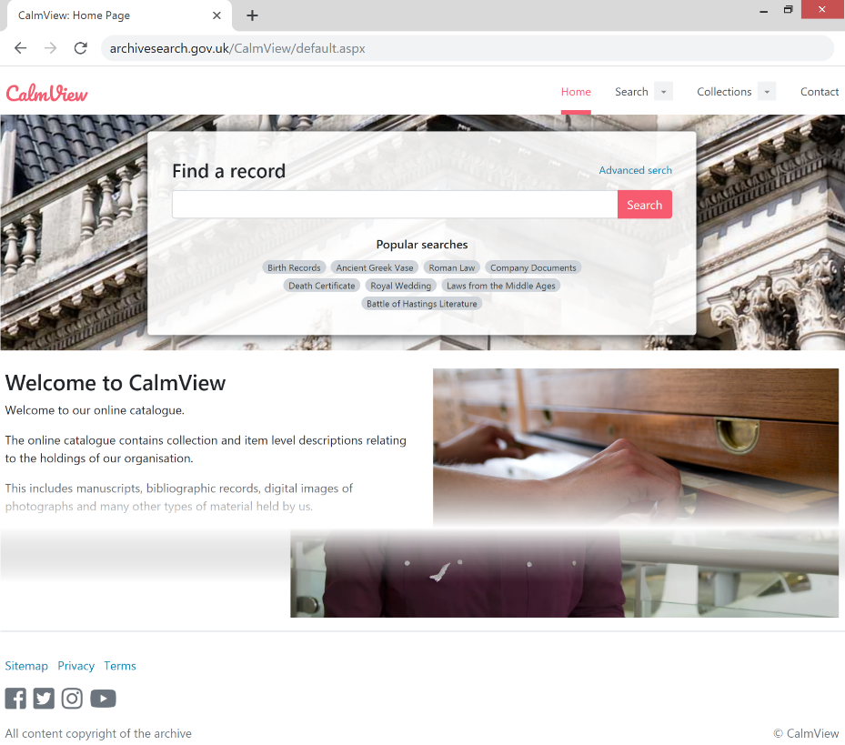
10
9

8
7
6
5
4
3
2
# | Element | Default | Custom
1 | Page name prefix | CalmView: | Click here to enter text.
2 | Header logo  Best if .svg. Can be .png, .gif, .jpg. | brand-logo.svg | Click here to enter text.
3 | Header background colour | White (#ffffff) | Click here to enter text.
4 | Header active link colour | Light Red (#F75B70) | Click here to enter text.
5 | Link colour | Light Blue (#0084b4) | Click here to enter text.
6 | Primary button colour | Light Red (#F75B70) | Click here to enter text.
 | Secondary button colour | Dark Grey (#6c757d) | Click here to enter text.
7 | Heading colour | Black (#000000) | Click here to enter text.
8 | Default font family | Segoe UI, Arial, Helvetica Neue, Roboto, sans-serif | Click here to enter text.
9 | Footer background colour | White (#ffffff) | Click here to enter text.
10 | Footer text colour | Dark Grey (#6c757d) | Click here to enter text.

Home page
The home page is the first page a visitor sees upon arriving at your CalmView site. It contains the configurable elements below.

Banner image
This image will be shown behind the search box. It is best as a .jpg or .png. It should have large dimensions and be under 1 MB. Please provide the filename below.
Click here to enter text.

Popular searches
Below the search box, you can suggest searches to visitors (e.g. ‘Parish registers’). Clicking one of these will search for the words in the popular search. To use these, please provide 5-10 below.

‘Browse the collection’ button
This button appears below the welcome text and by default links to the Showcase. If you would like to change the button text or the link destination, please enter that in the Custom column below.
Element | Default | Custom
Text | Browse the collection | Click here to enter text.
Link | [CalmView]\showcase.aspx | Click here to enter text.

Welcome text
Enter any welcome text you would like displayed on the home page below. The default text is shown at left.
Default | Custom
Welcome to CalmView  Welcome to our online catalogue.  The online catalogue contains collection and item level descriptions relating to the holdings of our organisation.  This includes manuscripts, bibliographic records, digital images of photographs and many other types of material held by us.  Please click on "About the catalogue" for more information on content, or one of the Search options to enter the catalogue. | Click here to enter text.

Carousel images
CalmView can cycle through a small number of images on the home page. It is best if these images are all the same dimensions, and it is best if they are .jpg or .png files under 1 MB. If you would like to display carousel images, please provide the filenames below. Captions can also be added over the bottoms of the images if you would like—just provide them below.
Filename | Caption
Click here to enter text. | Click here to enter text.
Click here to enter text. | Click here to enter text.
Click here to enter text. | Click here to enter text.
Click here to enter text. | Click here to enter text.
Click here to enter text. | Click here to enter text.

Embedded video
A video from a site like YouTube, as well as a title, subtitle, and description, can be shown on the home page. If you would like to display this, please enter the details below.
Video URL | Click here to enter text.
Title | Click here to enter text.
Subtitle | Click here to enter text.
Description | Click here to enter text.

Header, Sidebar, and Footer
The header, sidebar, and footer are displayed on most pages in CalmView (the sidebar is not shown on the home page) and provide navigational aids and extra content.

Sidebar position
The sidebar can appear on either side of the screen.
Element | Default | Custom
Sidebar position | Right | Choose an item.

Useful Links
A series of useful links can be displayed in the sidebar to any site you wish—instructions on how to use the archive, interesting collections in your holdings, external archives search sites, or anything else. If you would like to display this, please enter the details below.
Display Text | URL
Click here to enter text. | Click here to enter text.
Click here to enter text. | Click here to enter text.
Click here to enter text. | Click here to enter text.
Click here to enter text. | Click here to enter text.
Click here to enter text. | Click here to enter text.

Twitter feed
A Twitter feed can be displayed in the sidebar, showing the newest content from this source. If you would like to display this, please enter the URL of the Twitter profile or list below (results for a specific hashtag cannot be displayed).
Click here to enter text.

Instagram image
An image from Instagram can be displayed in the sidebar, showing a specific photograph from that source. If you would like to display this, please enter the URL of the Instagram image below.
Click here to enter text.

Footer
At the bottom of each page, a footer is displayed. This has links to reference pages (such as your privacy notice), social media sites, and a message at the bottom, all of which can be configured. To edit the contents of the Privacy page or Terms page, see Other Pages, below.
Elements | Default | Custom | Exclude?
‘Sitemap’ link text | Sitemap | Click here to enter text. | Choose an item.
‘Privacy’ link text | Privacy | Click here to enter text. | Choose an item.
‘Terms’ link text | Terms | Click here to enter text. | Choose an item.
Footer message |  | Click here to enter text.
Links to several social media sites can be displayed in the footer as icons. If you would like to display this, please enter the URLs of your organisation’s social media sites below.

Site | URL
Facebook | Click here to enter text.
Twitter | Click here to enter text.
Instagram | Click here to enter text.
YouTube | Click here to enter text.
Click here to enter text. | Click here to enter text.
Click here to enter text. | Click here to enter text.

Showcase
The Showcase, if you wish to use it, holds a selection of records, corresponding images, and text for each one. It allows you to highlight underappreciated records, make a small online exhibition, or serve up your most important items. Showcase records can also be displayed on the home page and in the sidebar.

Display
Element | Default | Custom
Display on home page | Yes | Choose an item.
Title | Showcase items | Click here to enter text.
Subtitle | A list of our latest and most exciting new items | Click here to enter text.
Button text | Explore Showcase | Click here to enter text.
Display on sidebar | Yes | Choose an item.

Records
The showcase can include as many or as few records as you would like, but we recommend somewhere between 4 and 15. You can write a custom Description and Title or, if you would like to use a field from the record, include just the name of that field in the column. The image you use must already be attached to the record. To check its filename, open the record in Calm and press F9.
Image file name | Record RefNo (or other ID) | Description (optional) | Title
Click here to enter text. | Click here to enter text. | Click here to enter text. | Click here to enter text.
Click here to enter text. | Click here to enter text. | Click here to enter text. | Click here to enter text.
Click here to enter text. | Click here to enter text. | Click here to enter text. | Click here to enter text.
Click here to enter text. | Click here to enter text. | Click here to enter text. | Click here to enter text.
Click here to enter text. | Click here to enter text. | Click here to enter text. | Click here to enter text.
Click here to enter text. | Click here to enter text. | Click here to enter text. | Click here to enter text.
Click here to enter text. | Click here to enter text. | Click here to enter text. | Click here to enter text.
Click here to enter text. | Click here to enter text. | Click here to enter text. | Click here to enter text.
Click here to enter text. | Click here to enter text. | Click here to enter text. | Click here to enter text.
Click here to enter text. | Click here to enter text. | Click here to enter text. | Click here to enter text.

Other pages

Contact Page
A contact page can contain a message to the user, an embedded map (from a site like Google Maps), and an address and other contact details. If you wish to use this, please enter the details below.
Message | Click here to enter text.
Link to map | Click here to enter text.
Address | Click here to enter text.

Privacy Notice
A link to a privacy page can exist in the footer. This can point at a general privacy page used by your organisation or a custom one specific to your CalmView site. Enter either the URL you wish this to point to or the text of the page below.
Default | Custom
Visitors to our websites  When someone visits our website we collect standard internet log information and details of visitor behaviour patterns.  We also record details of searches, records viewed and any errors encountered whilst using the web site.  Use of cookies  Cookies are small text files that are placed on your computer by websites that you visit. They are widely used in order to make websites work, or work more efficiently, as well as to provide information to the owners of the site.  The table below explains the cookies we use and why.  Cookie Name Purpose More information  ASP.NET Session cookie ASP. NET_ SessionId This cookie is essential for the operation of the website. This cookie is deleted when you close your browser. Visit the Microsoft website | Click here to enter text.

Terms & Conditions
A link to a terms page can exist in the footer. If you wish to use this, please enter the text you would like displayed on the page below.
Click here to enter text.

Search fields
You can display any number of fields in the Advanced Search, as well as change the label that is displayed to the user. If a field is set as ‘Expandable’, the user can search it normally or run an OR, AND, or NOT search when using more than one word in the field.
Several fields are set up by default as part of it. You can stay with just these, exclude some of them, or add other customer-chosen fields. To exclude any default fields, choose ‘Exclude’ in the column at right.

Default
Field name | Label displayed to user (optional) | Hover text (optional) | Expand-able? | Exclude?
RefNo | ReferenceNumber | Click here to enter text. | Yes | Choose an item.
Description | Click here to enter text. | Click here to enter text. | Yes | Choose an item.

Customer-chosen
Field name | Label displayed to user (optional) | Hover text (optional) | Expandable?
Click here to enter text. | Click here to enter text. | Click here to enter text. | Choose an item.
Click here to enter text. | Click here to enter text. | Click here to enter text. | Choose an item.
Click here to enter text. | Click here to enter text. | Click here to enter text. | Choose an item.
Click here to enter text. | Click here to enter text. | Click here to enter text. | Choose an item.

Overview fields
The Overview is what a user sees when a search returns multiple results. Several fields are set up by default as part of it. You can stay with just these, exclude some of them, or add other customer-chosen fields. To exclude any default fields, choose ‘Exclude’ in the column at right.

Default
Field name | Label displayed to user (optional) | Exclude?
RefNo | Ref No | Choose an item.
Title | Click here to enter text. | Choose an item.
Description | Click here to enter text. | Choose an item.

Customer-chosen
Field name | Label displayed to user (optional)
Click here to enter text. | Click here to enter text.
Click here to enter text. | Click here to enter text.
Click here to enter text. | Click here to enter text.
Click here to enter text. | Click here to enter text.

Record view fields
The record view is what a user sees when looking at a single record. Many fields are set up by default as part of it, but users only see fields that have data. You can stay with just these, exclude some of them, or add other customer-chosen fields. To exclude any default fields, choose ‘Exclude’ in the column at right.

Default
Field name | Label displayed to user (optional) | Clicking links to hierarchy? | Exclude?
RefNo | Ref No | Yes | Choose an item.
AltRefNo | Alt Ref No | No | Choose an item.
AccNo | Acc No | No | Choose an item.
Title | Click here to enter text. | No | Choose an item.
Description | Click here to enter text. | No | Choose an item.
Author | Click here to enter text. | No | Choose an item.
Artist | Click here to enter text. | No | Choose an item.
Date | Click here to enter text. | No | Choose an item.
Subject | Click here to enter text. | No | Choose an item.
Term | Click here to enter text. | No | Choose an item.
ObjectName | Object Name | No | Choose an item.
RelatedMaterial | Related Material | No | Choose an item.
PhysicalDescription | Physical Description | No | Choose an item.
Format | Click here to enter text. | No | Choose an item.
Category | Click here to enter text. | No | Choose an item.
URL | Click here to enter text. | No | Choose an item.
Image | Click here to enter text. | No | Choose an item.
Thumbnail | Click here to enter text. | No | Choose an item.
Document | Click here to enter text. | No | Choose an item.
Multimedia | Click here to enter text. | No | Choose an item.
Person_Code | Click here to enter text. | No | Choose an item.
Place_Code | Click here to enter text. | No | Choose an item.

Customer-chosen
Field name | Label displayed to user (optional) | Clicking links to hierarchy?
Click here to enter text. | Click here to enter text. | Choose an item.
Click here to enter text. | Click here to enter text. | Choose an item.
Click here to enter text. | Click here to enter text. | Choose an item.
Click here to enter text. | Click here to enter text. | Choose an item.

Hierarchy fields
The hierarchy browser always displays data from the field used to make the hierarchy (usually RefNo). After that, it displays the Title, but you can choose one or more fields to display instead.
Element | Default | Custom
Fields to display | Title | Click here to enter text.

Image watermarks
To protect copyright, images can be watermarked with an image, text, both, or none.
Element | Default | Custom
Copyright message | © Copyright | Choose an item.
Watermark file name  Best if .png | watermark.png | Click here to enter text.
Watermark vert. position | Bottom | Choose an item.
Watermark horiz. position | Right | Choose an item.
Apply to which image? | Both | Choose an item.

Additional changes
By default, CalmView displays data from the Catalogue database. It can also be configured to use other databases (the Names database and Places database are the most common choices).
Other databases to include (Tick for yes):
☐ Names | ☐ Places | ☐ Click here to enter text. | ☐ Click here to enter text.
If there are any other changes you would like made, please include them in the box below. This could include:
- adding other pages (for example, an ‘About the Catalogue’ page or ‘How to Search’ page),
- adding text to any page (for example, a blurb explaining the ‘Advanced Search’)
- changing anything else that doesn’t seem right
Please note: this is no guarantee that a particular change can be made.
Click here to enter text.

